1. **Create a vector of 100 randomly distributed numbers between 0 and 100 using runif and save the vector into the variable my_vec. What information does str and summary tell you about my_vec ? How do they differ?**

my_vec<-runif(100, min = 0, max = 100)

my_vec

str(my_vec)

summary(my_vec)

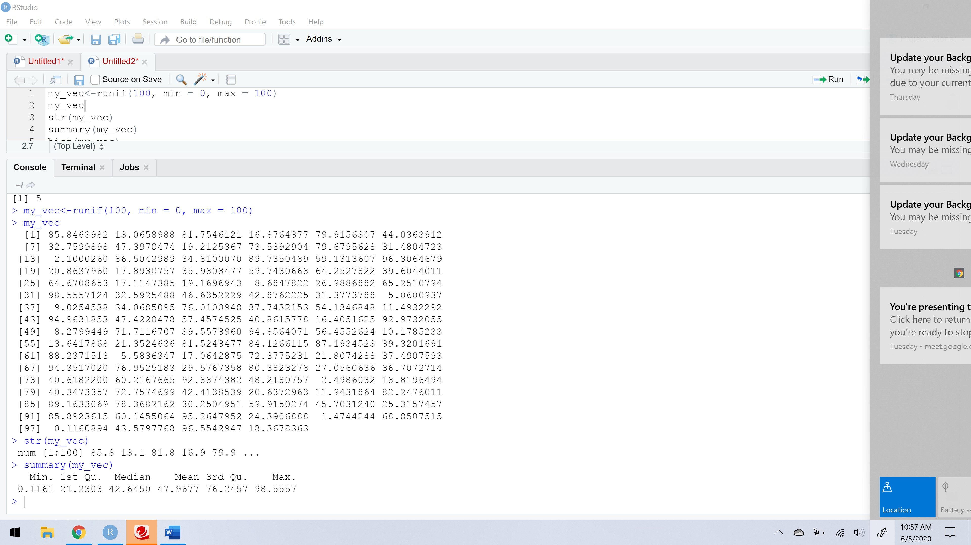

Str(my_vec) gives all the values in the 100 vectors, but summary(my_vec) give the min, 1st quadrant, median, mean, 3rd quadrant, and max values of 100 vectors.

1. **Try out a little plot. What does hist(my_vec) show you? What information does the helpfile for hist tell you about what you just did?**

hist(my_vec)

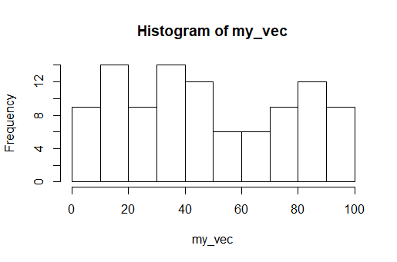

?hist

This Helpfile to identify the x which is a vector. So, this is helps to visualize the data of my_vec in historical representation. This command tells us about the hist as described below:

Histograms

**Description**

The generic function hist computes a histogram of the given data values. If plot = TRUE, the resulting object of [class](http://127.0.0.1:45975/help/library/graphics/help/class) "histogram"is plotted by [plot.histogram](http://127.0.0.1:45975/help/library/graphics/help/plot.histogram), before it is returned.

**Usage**

hist(x, ...)

## Default S3 method:

hist(x, breaks = "Sturges",

freq = NULL, probability = !freq,

include.lowest = TRUE, right = TRUE,

density = NULL, angle = 45, col = NULL, border = NULL,

main = paste("Histogram of" , xname),

xlim = range(breaks), ylim = NULL,

xlab = xname, ylab,

axes = TRUE, plot = TRUE, labels = FALSE,

nclass = NULL, warn.unused = TRUE, ...)

**Arguments**

|  |  |
| --- | --- |
| x | a vector of values for which the histogram is desired. |
| breaks | one of:   * a vector giving the breakpoints between histogram cells, * a function to compute the vector of breakpoints, * a single number giving the number of cells for the histogram, * a character string naming an algorithm to compute the number of cells (see ‘Details’), * a function to compute the number of cells.   In the last three cases the number is a suggestion only; as the breakpoints will be set to [pretty](http://127.0.0.1:45975/help/library/graphics/help/pretty) values, the number is limited to 1e6 (with a warning if it was larger). If breaksis a function, the x vector is supplied to it as the only argument (and the number of breaks is only limited by the amount of available memory). |
| freq | logical; if TRUE, the histogram graphic is a representation of frequencies, the countscomponent of the result; if FALSE, probability densities, component density, are plotted (so that the histogram has a total area of one). Defaults to TRUE *if and only if* breaks are equidistant (and probability is not specified). |
| probability | an *alias* for !freq, for S compatibility. |
| include.lowest | logical; if TRUE, an x[i] equal to the breaksvalue will be included in the first (or last, forright = FALSE) bar. This will be ignored (with a warning) unless breaks is a vector. |
| right | logical; if TRUE, the histogram cells are right-closed (left open) intervals. |
| density | the density of shading lines, in lines per inch. The default value of NULL means that no shading lines are drawn. Non-positive values of density also inhibit the drawing of shading lines. |
| angle | the slope of shading lines, given as an angle in degrees (counter-clockwise). |
| col | a colour to be used to fill the bars. The default of NULL yields unfilled bars. |
| border | the color of the border around the bars. The default is to use the standard foreground color. |
| main, xlab, ylab | main title and axis labels: these arguments to[title](http://127.0.0.1:45975/help/library/graphics/help/title)() get “smart” defaults here, e.g., the default ylab is "Frequency" iff freq is true. |
| xlim, ylim | the range of x and y values with sensible defaults. Note that xlim is *not* used to define the histogram (breaks), but only for plotting (when plot = TRUE). |
| axes | logical. If TRUE (default), axes are draw if the plot is drawn. |
| plot | logical. If TRUE (default), a histogram is plotted, otherwise a list of breaks and counts is returned. In the latter case, a warning is used if (typically graphical) arguments are specified that only apply to the plot = TRUE case. |
| labels | logical or character string. Additionally draw labels on top of bars, if not FALSE; see [plot.histogram](http://127.0.0.1:45975/help/library/graphics/help/plot.histogram). |
| nclass | numeric (integer). For S(-PLUS) compatibility only, nclass is equivalent to breaks for a scalar or character argument. |
| warn.unused | logical. If plot = FALSE and warn.unused = TRUE, a warning will be issued when graphical parameters are passed to hist.default(). |
| ... | further arguments and [graphical parameters](http://127.0.0.1:45975/help/library/graphics/help/graphical%20parameters)passed to [plot.histogram](http://127.0.0.1:45975/help/library/graphics/help/plot.histogram) and thence to [title](http://127.0.0.1:45975/help/library/graphics/help/title) and [axis](http://127.0.0.1:45975/help/library/graphics/help/axis) (if plot = TRUE). |

1. **Load up the mtcars data set using data(mtcars). Apply the following functions to mtcars: class, str, summary. What do these three functions tell you about mtcars?**

data(mtcars)

This loads data into the R environment.

class(mtcars)

This class function gives the vector of names of classes an object inherits.

str(mtcars)

It shows the column names and data type of each column and all the values in the columns.

summary(mtcars)

This shows the summary of each column min, 1st quadrant, median, mean, 3rd quadrant, max

values.

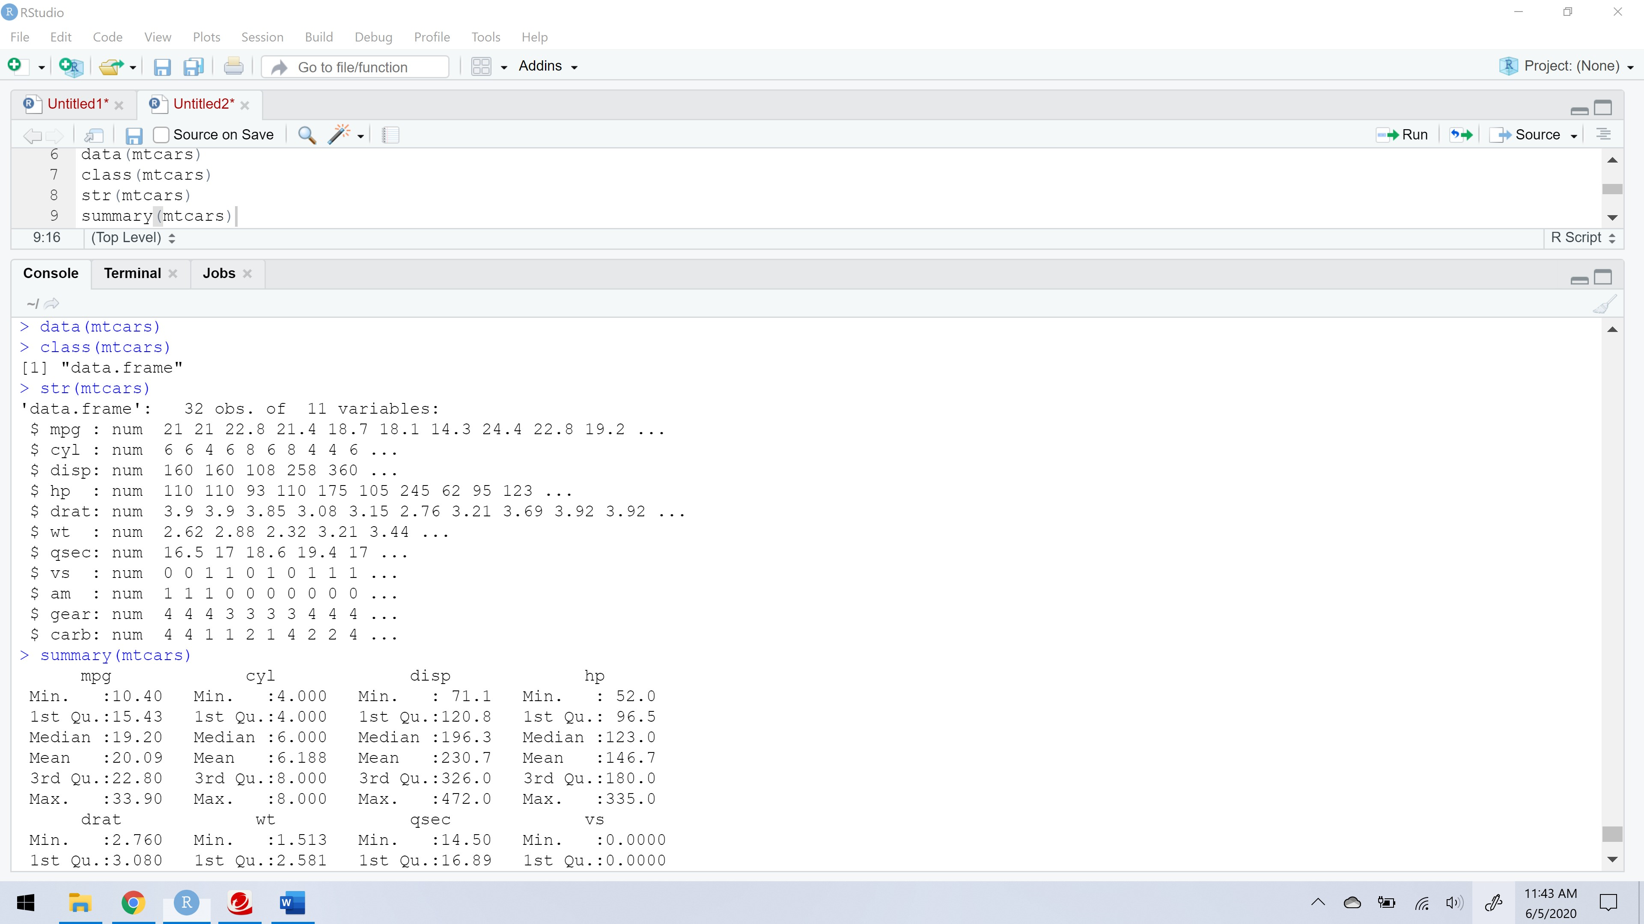

1. **Look at the help file for the class data.frame . What does it tell you about these objects?**

?class

This class function defines the class of the objects called x. This command helps us to learn about the class as mentioned below:

## Object Classes

### Description

**R** possesses a simple generic function mechanism which can be used for an object-oriented style of programming. Method dispatch takes place based on the class of the first argument to the generic function.

### Usage

class(x)

class(x) <- value

unclass(x)

inherits(x, what, which = FALSE)

oldClass(x)

oldClass(x) <- value

### Arguments

|  |  |
| --- | --- |
| x | a **R** object |
| what, value | a character vector naming classes. value can also be NULL. |
| which | logical affecting return value: see ‘Details’. |

?data.frame

This defines the fundamental data structure in most of the R. This is a thickly combined collection of different variables which defines the dataset attributes. This data frame is used to store the data table. It is a list of vectors of equal length.

This command helps us to learn in detail about data frames definition, usage, arguments, details, value, Examples.

## Data Frames

### Description

The function data.frame() creates data frames, tightly coupled collections of variables which share many of the properties of matrices and of lists, used as the fundamental data structure by most of **R**'s modeling software.

### Usage

data.frame(..., row.names = NULL, check.rows = FALSE,

check.names = TRUE, fix.empty.names = TRUE,

stringsAsFactors = default.stringsAsFactors())

default.stringsAsFactors()

### Arguments

|  |  |
| --- | --- |
| ... | these arguments are of either the form value or tag = value. Component names are created based on the tag (if present) or the deparsed argument itself. |
| row.names | NULL or a single integer or character string specifying a column to be used as row names, or a character or integer vector giving the row names for the data frame. |
| check.rows | if TRUE then the rows are checked for consistency of length and names. |
| check.names | logical. If TRUE then the names of the variables in the data frame are checked to ensure that they are syntactically valid variable names and are not duplicated. If necessary they are adjusted (by [make.names](http://127.0.0.1:45975/help/library/base/help/make.names)) so that they are. |
| fix.empty.names | logical indicating if arguments which are “unnamed” (in the sense of not being formally called as someName = arg) get an automatically constructed name or rather name "". Needs to be set to FALSE even when check.names is false if "" names should be kept. |
| stringsAsFactors | logical: should character vectors be converted to factors? The ‘factory-fresh’ default is TRUE, but this can be changed by setting [options](http://127.0.0.1:45975/help/library/base/help/options)(stringsAsFactors = FALSE). |

1. **What kind of data are you thinking about working with for your final project? Give me a brief description of the data**

I have considered a data which consists of data about candy. To analyze the data in the dataset, str command tells us the column datatypes. Summary command helps us to understand the range of data values in each column.

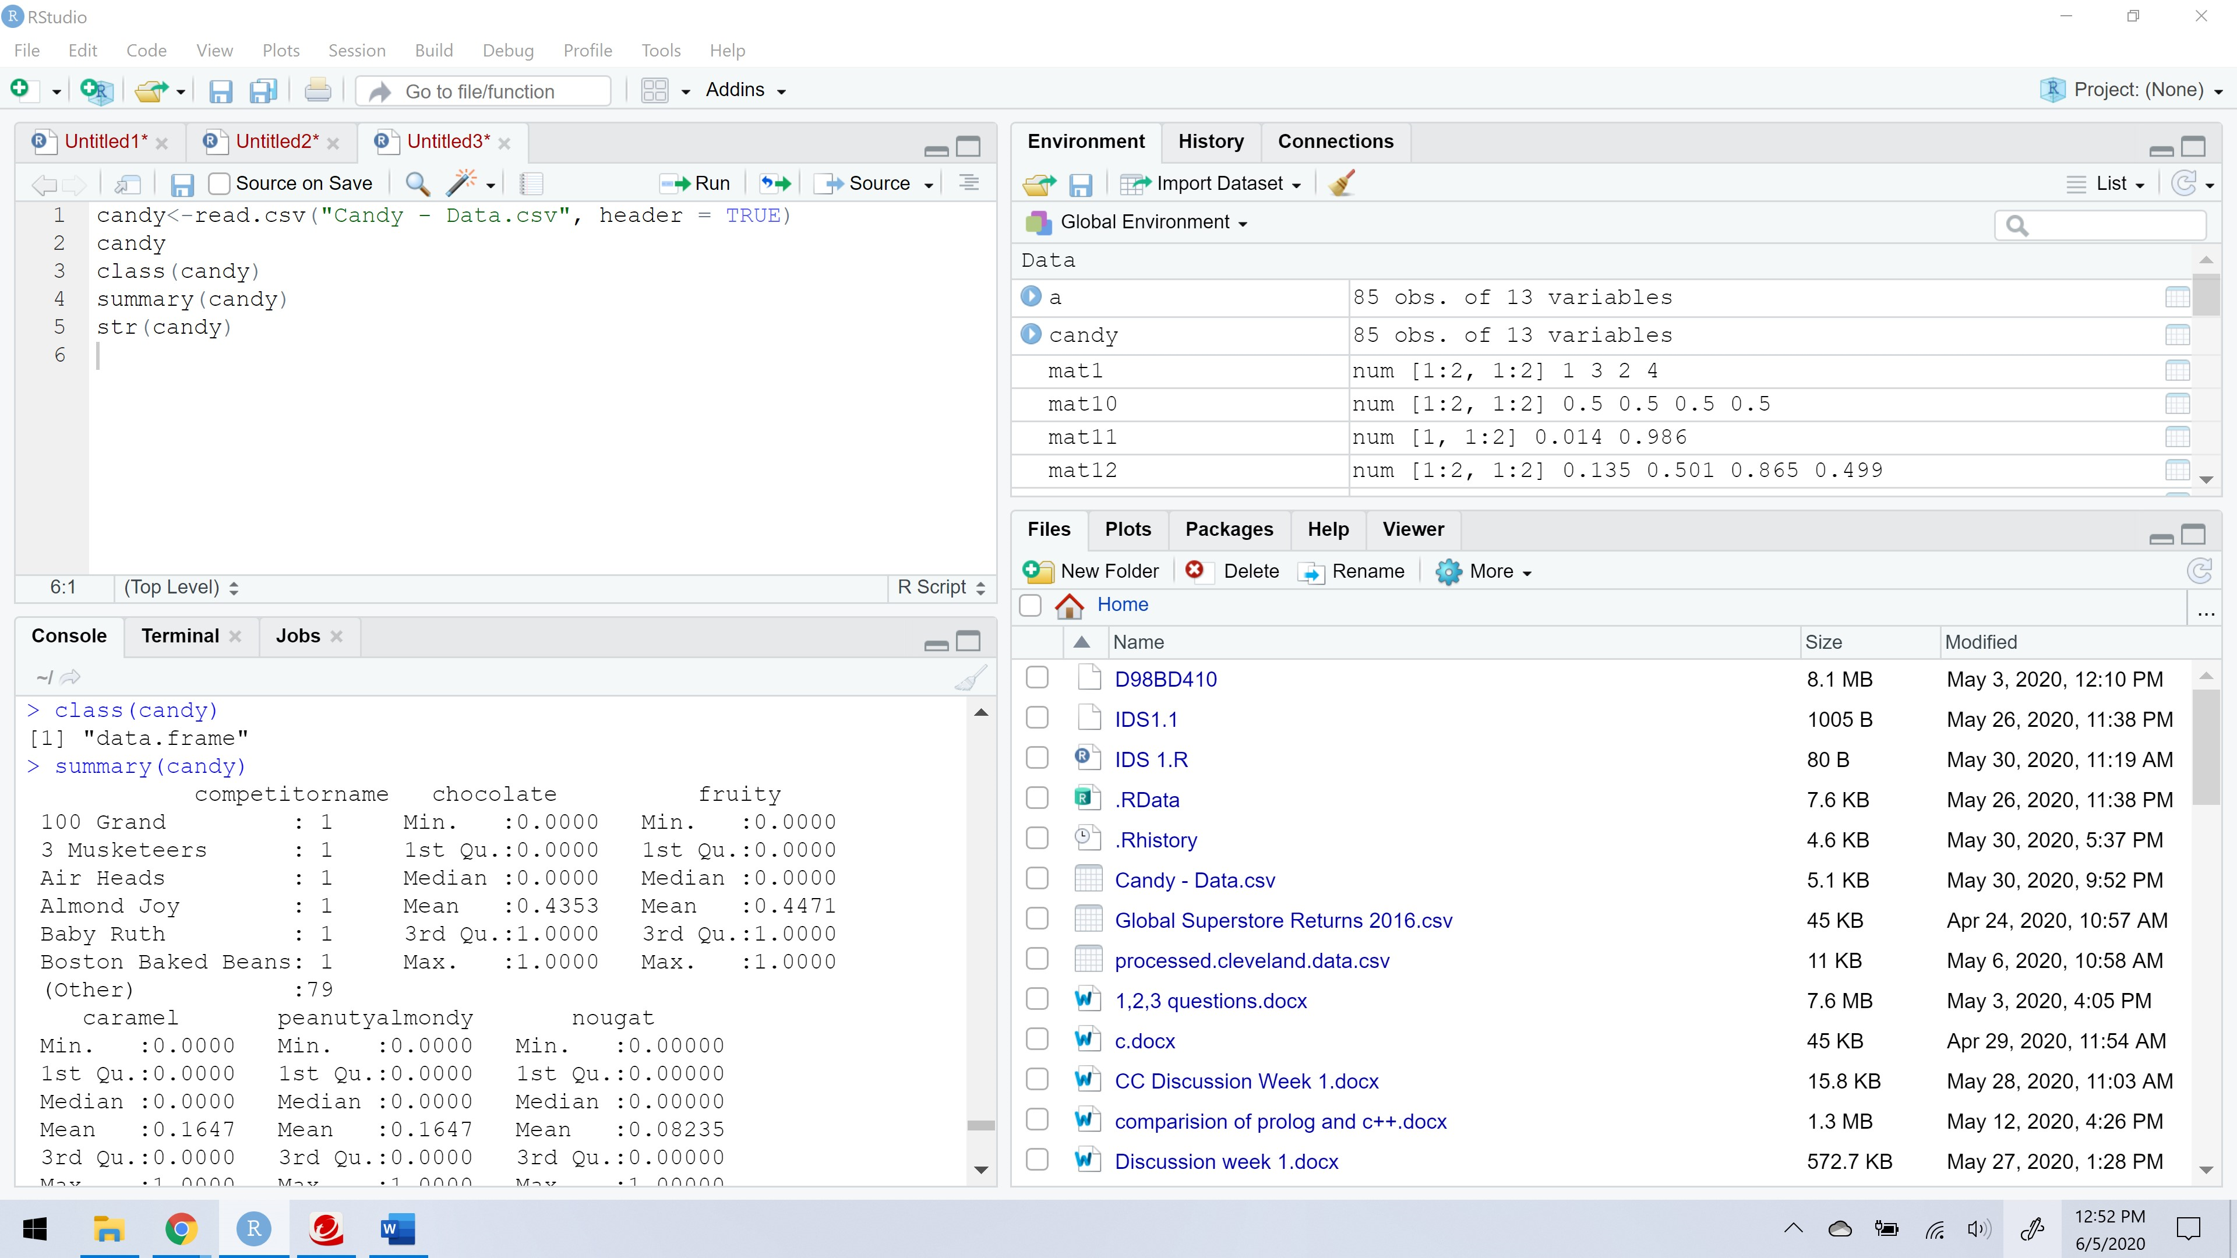

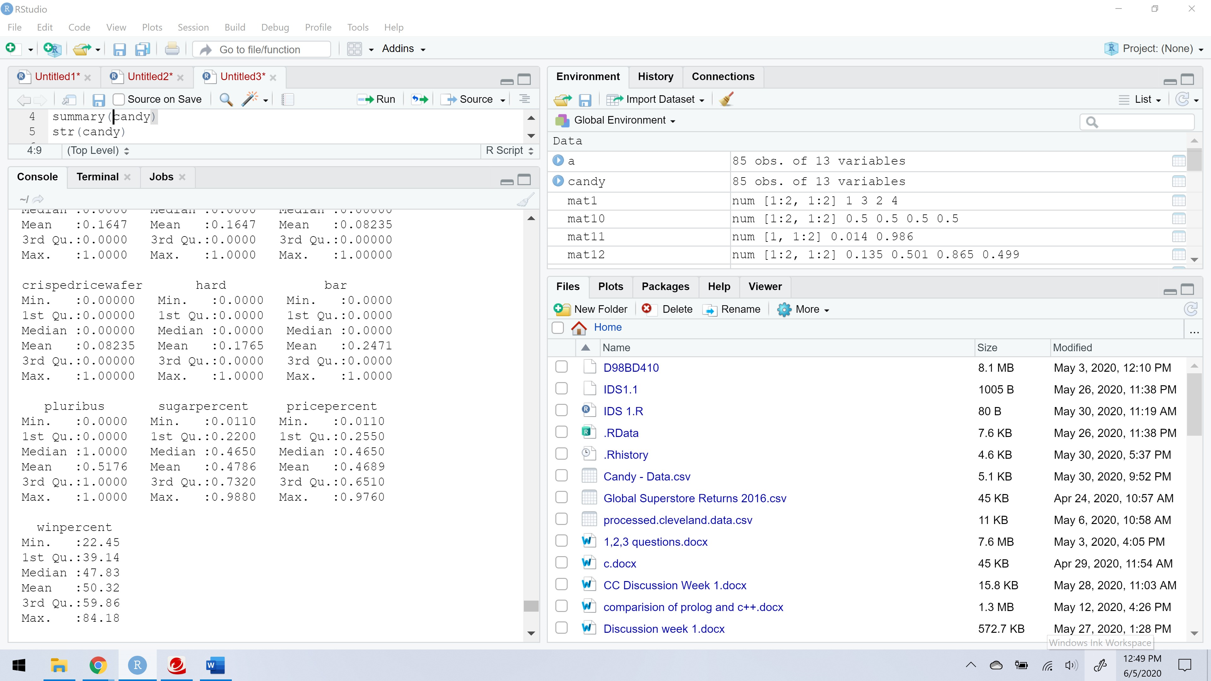

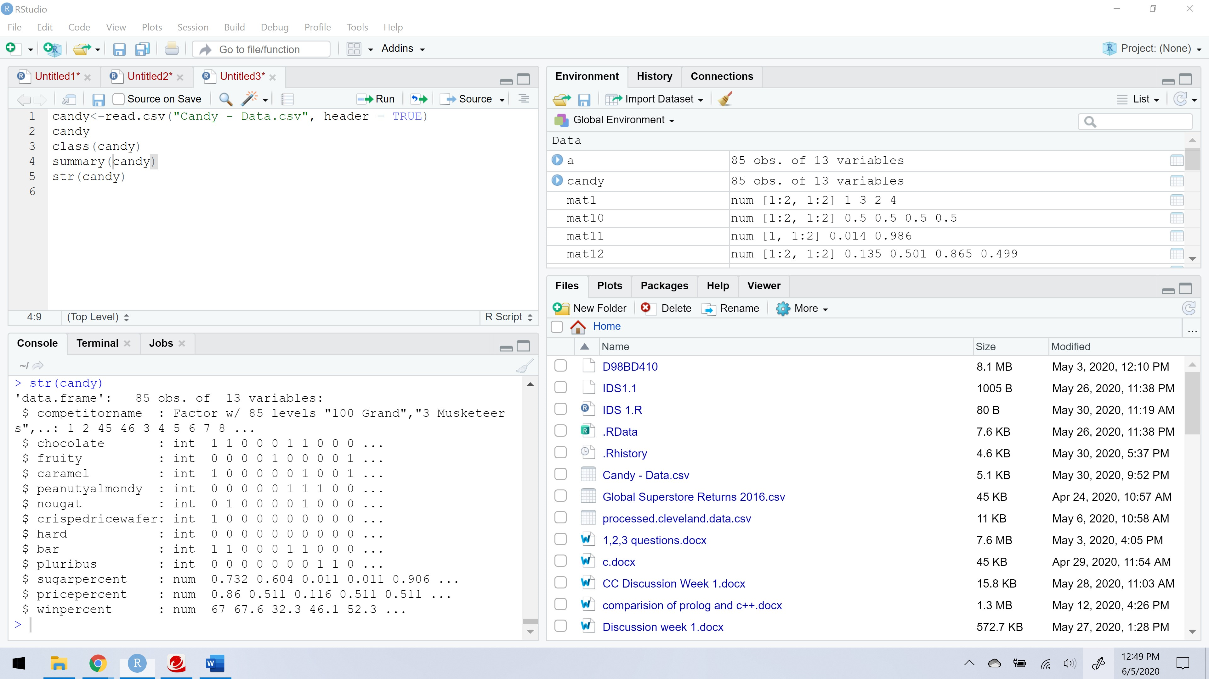

**10th question in Dynamic Report**

**Without running the following code in R, try to determine which of the following will return the first three rows of the Sepal.Length column in the iris data.frame? For each of the answers that do not work, see if you explain why!**

a. iris[c(1, 2, 3), ‘Sepal.Length’]

This is correct answer, that will satisfy the given requirement.

b. iris[1, 2, 3, ‘Sepal.Length’]

This is wrong answer, because of the multiple commas between the numbers that indicate only rows but usually we use single comman to separate rows and columns.

c. iris[(1, 2, 3), ‘Sepal.Length’]

This is also a wrong answer, there should is syntax error.

d. iris[‘Sepal.Length’, c(1, 2, 3)]

This is a correct syntax, but it doesn’t met the requirement given in the question.